Axiom Requisition Copy Service
2869 Jolly Road, Okemos, Michigan 48864
517.886.5099 – 877.886.5090 toll free – 517.886.4116 facsimile – records@axiomcopy.com

REQUEST FOR RECORDS - ORDER NUMBER 01-29018-001

TO THE CUSTODIAN OF RECORDS Date Sent: November 8, 2026
Gotham City Hospital Anesthesiology
Dept.

,
Please find enclosed a request for records of:
Batman
DOB 01/01/1979 SSN xxx-xx-5555
We are requesting the following:

USE FOR WILLIAM DEARBAUGH:FROM 01/01/1979 TO PRESENT: Any and all MEDICAL RECORDS and FILMS (ON CD IF AVAILABLE). FROM TO PRESENT: BILLING RECORDS including but not limited to patient history form(s), and itemized write offs and billing payments, etc. pertaining to Batman SSN: xxx-xx-5555, DOB: 01/01/1979.

INSTRUCTIONS
- FORWARD INVOICE WITH RECORDS – If fee is greater than $50.00 Pre-approval is required
- PLEASE DO NOT STAPLE DOCUMENTS.
- Mail, email or fax the records to: Axiom Requisition Copy Service (as agent of John Doe, Smith and Jones PC), 2869 Jolly Road, Okemos, MI 48864 – Phone: 517.886.5099 – Fax: (517) 886-4116 – Email: records@axiomcopy.com.

SIGN AND RETURN THIS FORM WITH THE REQUESTED RECORDS
__________________________________________________________
CERTIFICATION OF RECORD SUBMISSION
I certify in response to the request issued to me, that I have submitted a true and complete copy of all requested documents in my control or possession relating to the above person; and that (A) The record was made at or near the time of the occurrence of the matters set forth by, or from information transmitted by, a person with knowledge of those matters; (B) The record was kept in the course of the regularly conducted business activity; and (C) It was the regular practice of the business activity to make the record.

_____________________________________________ _____________________
Signature of the custodian of records Date

If you are sending only part of the documents requested above and some are not in your possession, please check the appropriate boxes below:
- No Medical Records ◻ No X-Ray Films ◻ No Photographs ◻ No Billing Records
If you do not have any of the records requested, please contact our office for an affidavit of no records or send us a letter on your letterhead stating you do not have any of the records requested.

ORDER NUMBER 01-29018-001

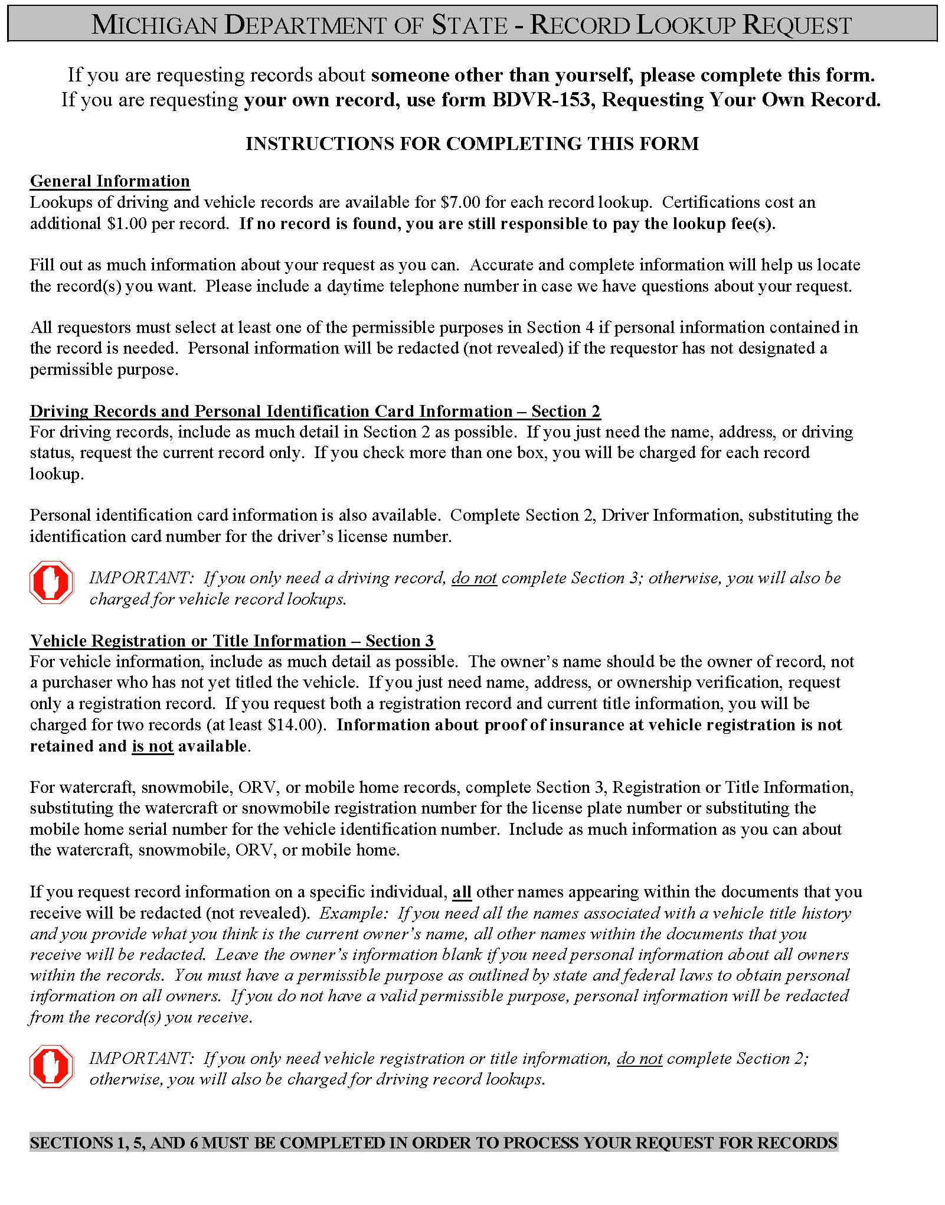

Michigan Department of State – Record Lookup Request
If you are requesting records about someone other than yourself, please complete this form.
If you are requesting your own record, use form BDVR-153, Requesting Your Own Record.
Section 1. Requestor (Please print or type all information.)
Requestor Name (Individual or Company)  Axiom Requisition Copy Service |  |  |  |  |  |  |  |  |  |  |  |  |  |  |  |  |  |  |  | Agent’s Name and Title (if company)  , Account Executive
Mailing Address  2869 Jolly Road |  |  |  |  |  |  |  |  |  |  |  |  |  |  |  |  |  |  |  |  |  |  |  |  |  |  |  |  |  |  |  |  |  |  |  |  |  |  | File or Claim Number
City  Okemos |  |  |  |  |  |  |  |  |  |  |  |  | State  Michigan |  |  |  |  |  | Zip Code  48864 |  |  |  |  |  |  |  |  |  |  |  |  |  |  |  |  |  |  |  | Daytime Telephone Number  (877) 886-5090
Section 2. Driver Information (If you only want a driving record, leave Section 3 blank.)
☑ Driving Record for:  (Shows last reported address) |  |  |  |  |  |  |  | - Employment or Insurance  - Court  ☑ Other: Legal Matter
☑ Current Application  ◻ Application History*  ◻ Address History* |  |  |  |  |  |  |  | } |  | For partial histories, please complete: from _____/_____/_____ to _____/_____/_____
◻ Other Driving-Related Record(s) _________________________________________________________Date_____/_____/_____
(Hearing, Offense, License Status, etc.)
Driver’s Full Name (First, Middle, Last) |  |  |  |  |  |  |  |  |  |  |  |  |  | Driver’s License Number  01/01/1979 |  |  |  |  |  |  |  |  |  |  |  |  |  |  |  |  |  |  |  |  |  |  |  |  |  |  |  |  | Date of Birth Date
Batman
Driver’s Full Name (First, Middle, Last) |  |  |  |  |  |  |  |  |  |  |  |  |  | Driver’s License Number |  |  |  |  |  |  |  |  |  |  |  |  |  |  |  |  |  |  |  |  |  |  |  |  |  |  |  |  | Birth Date
Section 3. Vehicle Registration or Title Information (Insurance information is not retained and is not available.)
Note: $7.00 is charged for each record lookup. Complete histories can be expensive.
(If you only need a vehicle record, leave Section 2 blank; otherwise, you will be charged for multiple records.)
License Plate or  Registration Number |  |  |  |  |  |  | Vehicle  Year |  |  |  | Make and Model |  |  |  |  |  |  | Vehicle or Hull Identification Number
Check boxes that apply:
◻ Current Vehicle Owner and Lienholder Information
◻ Registration Information as of _____/_____/_____
◻ Copy of Current Title Application and Related Forms
◻ Complete Title History*
☑ Complete Registration History*
- Partial Title History*  - Partial Registration History* |  |  |  |  |  |  |  |  |  |  | } | For partial histories, please complete: from _____/_____/_____ to _____/_____/_____
Check box if you want: |  |  |  |  |  |  | - All motor vehicles registered or titled to this owner.**  - All other registered or titled assets for the owner indicated.**
Vehicle Owner(s) Name
Batman
Vehicle Owner(s) Address
Secret Location Under Office Building
City  Gotham |  |  |  |  |  |  |  |  |  |  |  |  |  |  |  |  |  | State  Michigan |  |  |  |  |  |  |  |  |  |  |  |  |  |  |  |  |  |  |  |  |  |  |  | Zip Code
* Buying a complete or partial title, application, and/or address history can be very expensive. The lookup fee is charged for each address or title change or correction.  ** When requesting records for all motor vehicles or all assets registered and/or titled thru the Michigan Department of State for individuals and/or companies, precise information is required. Information retrieved is based upon an exact name and address match. The individual’s name and address, as provided by the record requestor, must match the name and address on the record(s) held by the Michigan Department of State. |  |  |  |  |  |  |  |  |  |  |  |  |  |  |  |  |  |  |  |  |  |  |  |  |  |  |  |  |  |  |  | For Office Use Only
 |  |  |  |  |  |  |  |  |  |  |  |  |  |  |  |  |  |  |  |  |  |  |  |  |  |  |  |  |  |  |  | BDVR-154-WEB (02/08)
SECTIONS 1,5, AND 6 MUST BE COMPLETED IN ORDER TO PROCESS YOUR REQUEST FOR RECORDS

Order No. 01-29018 - 001
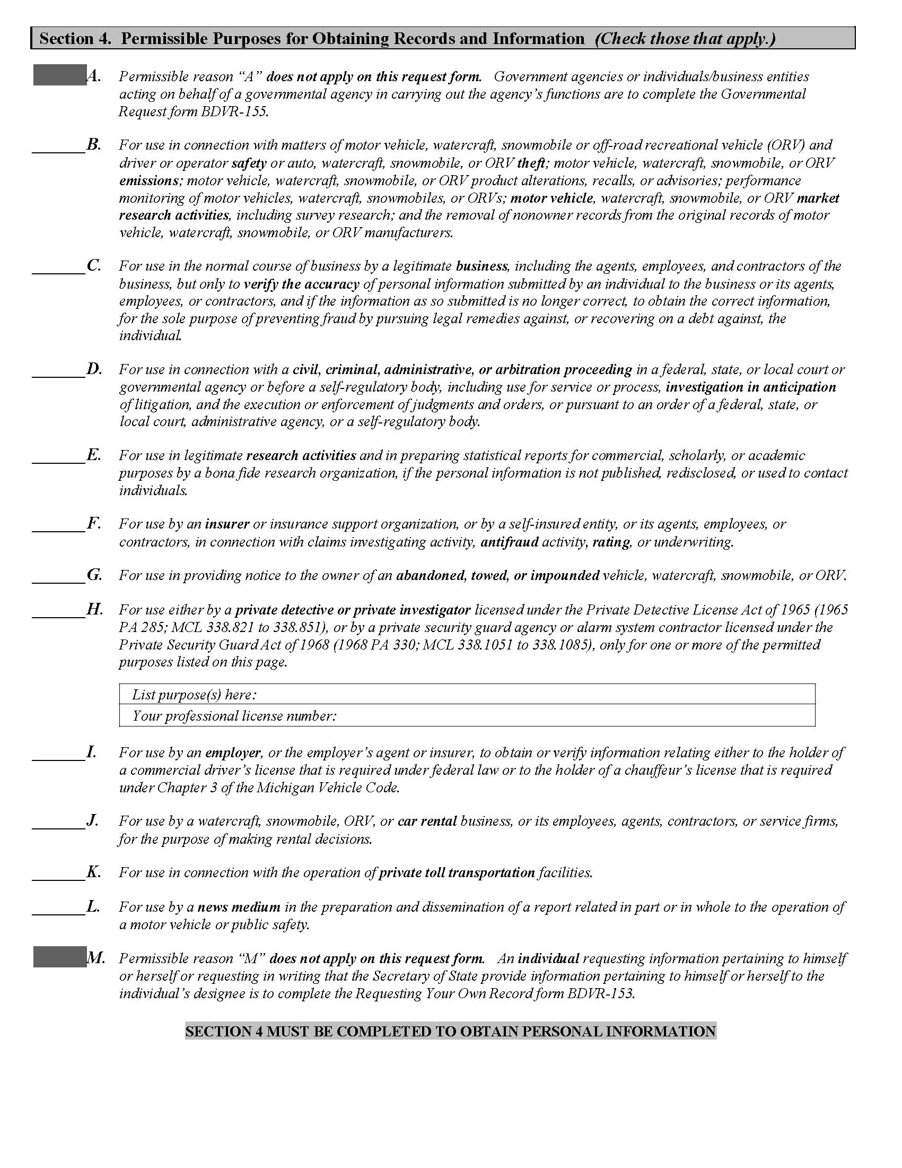
X
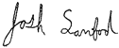
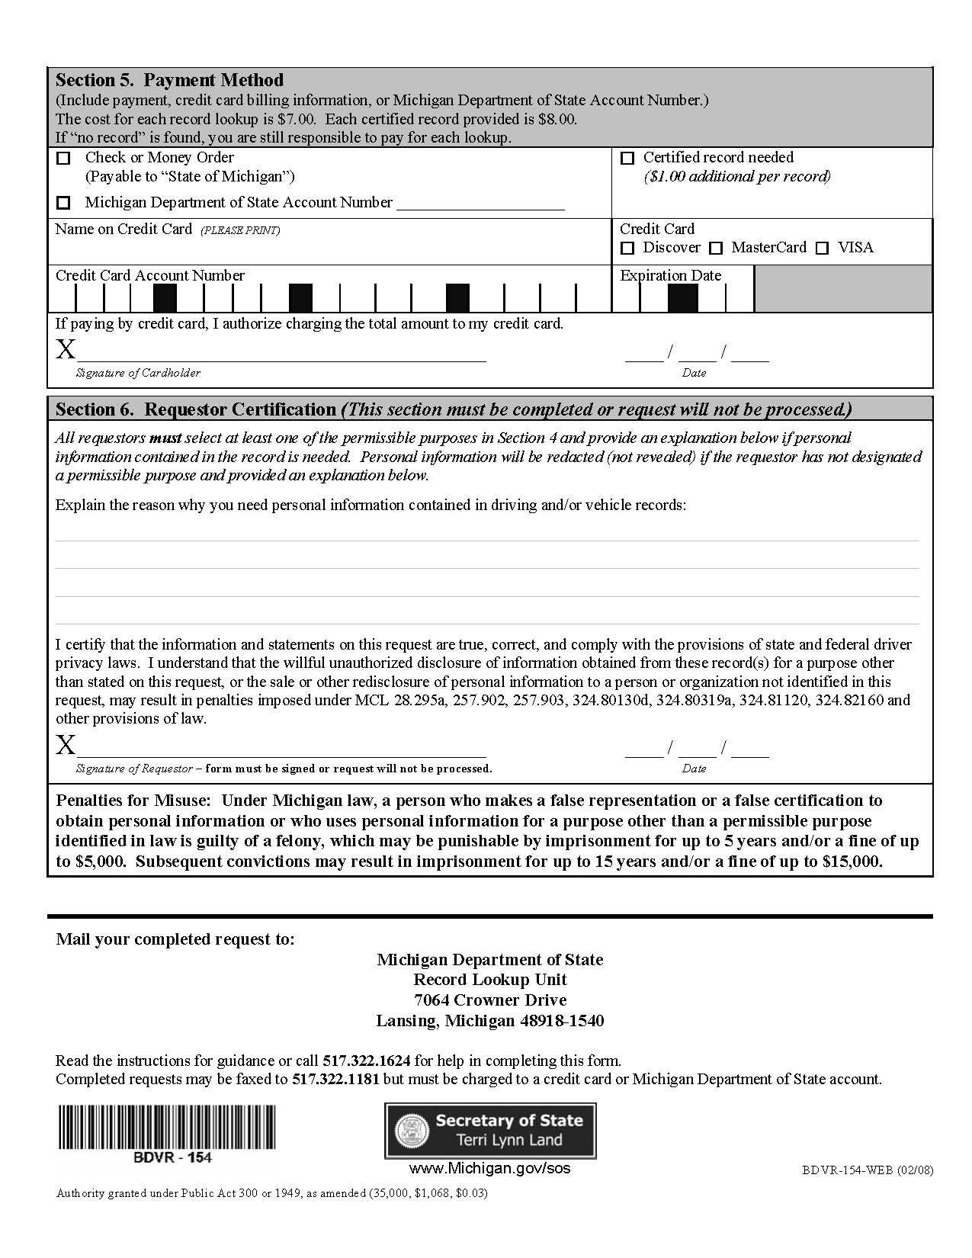
Legal Action of

